

CO2 ASSESSMENT TOOL 2 – Architecture Design Assignment

CSA1012
SOFTWARE ENGINEERING

Project: SmartCare Assets — Intelligent Hospital Asset Tracking
and Equipment Management Platform
Field | Details
Course Code | CSA1012
Course Title | Software Engineering
CO Assessed | Perform detailed requirements analysis, design scalable architectures, and prioritize features with a focus on cross-disciplinary skills
Assessment | Assessment Tool 2 – Architecture Design Assignment
Student Name | Ashwin S
Register No. | 192311410
Date | August 2026

Annexure A – Architecture Design Assignment
Assigned Problem Statement: Intelligent Hospital Asset Tracking and Equipment Management Platform — an RFID/BLE/IoT-based system for real-time location tracking, condition monitoring, and predictive maintenance of shared medical equipment across hospital departments.

1. Analyze System Requirements

1.1 System Objectives
The system is intended to give hospital staff continuous, reliable visibility into the location and condition of shared medical equipment, replacing manual checkpoint tracking and calendar-based maintenance with real-time monitoring and predictive maintenance. Its objectives are to track every registered asset's location, continuously monitor its condition through IoT sensors, detect and predict maintenance needs before failure, automate alerting and maintenance work orders, and present role-based dashboards to nurses, biomedical engineers, and administrators.

1.2 Functional Requirements Influencing the Architecture
- User authentication and role-based access control across at least four distinct roles.
- Registration of assets and association of RFID/BLE tracking devices, with duplicate-ID validation.
- Ingestion of continuous, high-frequency location and sensor telemetry from many concurrent devices.
- Rule-based and machine-learning-based evaluation of maintenance risk.
- Automated alert generation and maintenance work-order tracking.
- Role-based dashboards with near real-time data.

1.3 Non-Functional Requirements Influencing the Architecture
- Performance: dashboards must reflect new location or condition events within a few seconds, which rules out architectures that only support batch or polling-based updates.
- Scalability: the system must grow from a single department to a hospital-wide or multi-hospital deployment without redesign, which favors independently scalable components over a single monolithic process.
- Reliability and availability: loss of a single reader, gateway, or service instance must not bring down the whole platform or silently drop a critical maintenance alert.
- Security: role-based access control and encrypted communication are required throughout, since the system touches operational hospital data.
- Maintainability: the rule engine, the ML model, and the alerting workflow evolve at different rates and must be updatable independently of one another and of the core tracking logic.

1.4 Key Quality Attributes
Quality Attribute | Why It Matters for This System
Scalability | Growth from one department to a multi-hospital network with a rising volume of concurrent IoT/RFID/BLE events.
Maintainability | The ML model, rule thresholds, and workflows are expected to change frequently and independently as more data accumulates.
Reliability | A missed or duplicated maintenance alert has direct patient-safety consequences.
Availability | Clinical staff depend on the system during time-critical care, so downtime directly affects hospital operations.
Performance | Location and status updates must reach dashboards in near real time to be operationally useful.
Security | The platform is part of hospital infrastructure and must protect operational data with authentication, authorization, and encryption.

2. Select a Suitable Software Architecture

2.1 Selected Architectural Style
A hybrid architecture combining Layered Architecture, Microservices, and Event-Driven Architecture is selected for this system, rather than any single style in isolation.

2.2 Justification
- Layered structure: a clear separation between the presentation layer (dashboards), the application layer (business logic as services), and the data layer keeps the system easy to reason about and matches how the platform was already decomposed in the earlier requirements and design work for this project.
- Microservices for independent evolution: the rule engine, the ML analytics engine, asset registration, tracking, and the maintenance workflow all change at different rates and depend on different skill sets (e.g. ML model retraining versus CRUD logic). Splitting these into independently deployable services means the ML model can be retrained and redeployed without redeploying the entire platform, directly satisfying the maintainability and scalability requirements identified in Section 1.
- Event-driven ingestion for high-frequency data: RFID/BLE and IoT devices generate a continuous, bursty stream of location and sensor events. A synchronous request/response call from every device reading would not scale and would couple the availability of edge devices to the availability of every downstream service. Routing this traffic through an event bus (Kafka) decouples ingestion from processing, so a temporary slowdown in the ML service does not block location tracking.
- Why not a pure monolith: a single monolithic application would be simpler to build initially, but would force the rule engine, ML analytics, and core tracking logic to scale and deploy together, which conflicts directly with the maintainability and scalability requirements — a change to the ML model would require redeploying and re-testing the entire system.
- Why not pure microservices without an event bus: using only synchronous REST calls between services for high-frequency location/sensor events would create tight coupling and cascading failure risk under load; the event-driven layer specifically addresses the performance and reliability requirements for that traffic.

3. Software Architecture Diagram
The diagram below shows the presentation layer, the API gateway, the microservices in the application layer, the event bus and edge processing layer that handle device traffic, the data layer, and the external systems the platform integrates with.
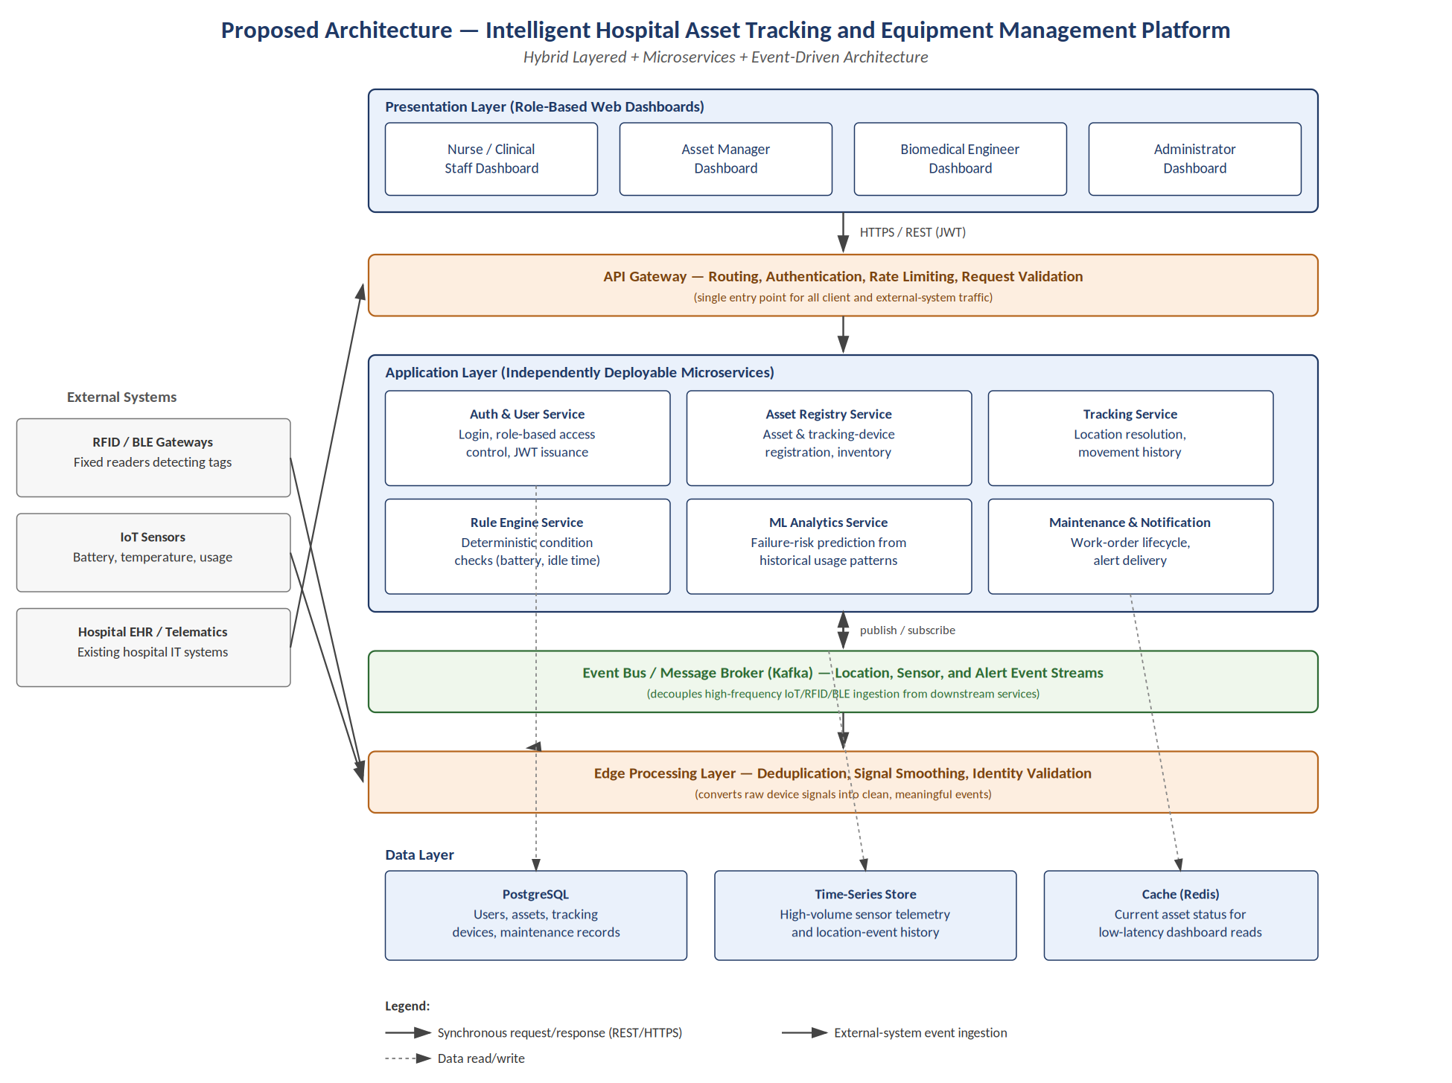
Figure 1: Proposed system architecture — hybrid layered, microservices, and event-driven design

4. Explain Components and Their Interactions

4.1 Component Responsibilities
Component | Responsibility
Presentation Layer | Role-based web dashboards for nurses, asset managers, biomedical engineers, and administrators.
API Gateway | Single entry point for all client and external traffic; handles routing, authentication, rate limiting, and request validation.
Auth & User Service | Login and issuance of JWT access tokens; enforces role-based access control.
Asset Registry Service | Asset registration, tracking-device association, and inventory management.
Tracking Service | Resolves current/last-known asset location and maintains movement history.
Rule Engine Service | Evaluates deterministic conditions (e.g. low battery, prolonged idle time, overdue maintenance).
ML Analytics Service | Predicts equipment failure risk from historical usage, condition, and maintenance data.
Maintenance & Notification Service | Creates and tracks maintenance work orders and delivers alerts to biomedical engineers.
Event Bus (Kafka) | Decouples high-frequency device event ingestion from the services that consume it.
Edge Processing Layer | Deduplicates, smooths, and validates raw RFID/BLE/IoT signals into clean events.
Data Layer | PostgreSQL for structured records, a time-series store for telemetry, and a cache for low-latency reads.

4.2 Communication Mechanisms
- Client to API Gateway: synchronous HTTPS/REST calls carrying a JWT bearer token issued at login.
- API Gateway to microservices: synchronous REST calls, routed and authenticated at the gateway before reaching a service.
- External devices to Edge Processing: RFID/BLE gateways and IoT sensors push raw readings into the edge processing layer, which validates and cleans them before publishing structured events.
- Edge Processing and services to the Event Bus: asynchronous publish/subscribe messaging, so the Rule Engine, ML Analytics, and Tracking services each consume the event stream independently and at their own pace.
- Services to the Data Layer: each service reads and writes only the data it owns (e.g. the Tracking Service owns location history), accessed through the ORM/data-access layer described in the earlier case-study report.

4.3 Overall Workflow
A tag or sensor reading is detected by an RFID/BLE gateway or IoT sensor and sent to the Edge Processing layer, which deduplicates and validates it before publishing a clean event to the Kafka event bus. The Tracking Service consumes location events to update current asset state; the Rule Engine and ML Analytics services consume condition/usage events in parallel to evaluate risk. When a risk threshold is exceeded, the Maintenance & Notification Service creates a work order and alerts the responsible biomedical engineer. Meanwhile, clients (nurses, asset managers, engineers, administrators) interact with the system entirely through the API Gateway, which routes authenticated requests to the Auth, Asset Registry, Tracking, or Maintenance services as appropriate, with all persistent state held in the data layer.

5. Discuss Quality Attributes
- Scalability: each microservice and the event bus can be scaled independently — for example, adding more Kafka partitions and edge-processing instances to absorb growth in tagged assets, without needing to scale the Auth or Maintenance services in proportion.
- Security: all client and external traffic passes through a single API Gateway that enforces authentication and role-based access control, and communication is encrypted in transit; each service also validates the caller's role independently rather than trusting the gateway alone, giving defense in depth.
- Performance: the event-driven ingestion path keeps high-frequency device traffic off the synchronous request path used by dashboards, and the Redis cache serves current-status reads without hitting the primary database on every dashboard refresh.
- Reliability: decoupling ingestion (edge processing/event bus) from processing (rule engine, ML service) means a slow or temporarily unavailable downstream service does not block location tracking or lose events, since Kafka retains the event stream until it is consumed.
- Maintainability: each service has a single, clearly bounded responsibility and can be modified, tested, and redeployed independently — most concretely, the ML Analytics Service's model can be retrained and redeployed without touching the Rule Engine, Tracking, or Asset Registry services.
- Availability: no single service failure takes down the whole platform; for example, if the ML Analytics Service is temporarily unavailable, the Rule Engine continues to catch deterministic conditions (e.g. low battery) and the Tracking Service continues to serve location queries.

6. Justify Architectural Decisions

6.1 Rationale
The architecture was chosen by working back from the non-functional requirements identified in Section 1 rather than from a preferred style. Scalability and maintainability pointed toward microservices over a monolith; the need to absorb high-frequency, bursty device traffic without coupling ingestion to every downstream consumer pointed toward an event-driven layer specifically for that traffic; and the need for a single, consistently enforced security boundary pointed toward a layered structure with one API Gateway as the sole entry point.

6.2 Trade-offs Considered
- Operational complexity versus flexibility: microservices and an event bus are more complex to deploy and operate than a single monolithic application. This cost was accepted because the alternative — a monolith — would directly conflict with the maintainability requirement once the ML model needs frequent, independent retraining and redeployment.
- Eventual consistency versus simplicity: asynchronous event processing means there can be a brief delay between a sensor reading and its effect being visible on a dashboard, rather than strict immediate consistency. This is an acceptable trade-off because the requirement is near real-time visibility, not hard real-time guarantees.
- More moving parts versus fault isolation: adding Kafka, a time-series store, and a cache increases the number of components to operate, but in return no single component failure can take down the entire platform, which was judged more important given the system's role in clinical operations.

6.3 Support for Future Enhancements and Long-Term Maintainability
- New capabilities (e.g. multi-hospital management, additional analytics) can be added as new services behind the same API Gateway without modifying existing services.
- The event bus makes it straightforward to add new consumers of the existing event stream — for example, a future audit/compliance service could subscribe to the same location and maintenance events without any change to the services that produce them.
- Because each service owns its own data access, individual services can later adopt different storage technologies if their access patterns diverge, without affecting the rest of the system.
- The clear boundary between deterministic rules (Rule Engine) and predictive analytics (ML Analytics Service) means the platform can keep operating safely on rules alone while the ML component is still accumulating the historical data it needs, consistent with the phased rollout defined in the project's Agile backlog.

